**We will only develop the tab in yellow**

**About Som Valley**

Mission / Vision

Gallery

* History
* From the Director's Desk

**Admission**

* The Admission Process
* Fee Structure
* Withdrawal Process
* Rules Regulations

**Academics**

* Overview
* Pre School
* Faculty
* Curriculum

**Extra Curricular / Other links**

* Co-Curricular Activities
* Community Service
* Art & Crafts
* Clubs

**Download**

**Link on the page**

Apply Online

Gallery

Events and news – We should be able to post the details and also image file.

**Contact Us**

Here are the details:

Website - [http://somvalley.in](http://somvalley.in/)

Facebook - <https://facebook.com/somvalleyinternationalschool/>

A temporary website - [http://beta.somvalley.in](http://beta.somvalley.in/)

-------------------------------------------------------------------------------

Ref site

<https://pps.ac.in/cbse/>  
<https://ebsm.mespune.in/>  
<https://pjoginstitutes.in/>  
<https://www.cisk.in/Home.aspx>  
<https://www.bvbpune.org/>  
<https://www.mitvgschools.edu.in/>  
<http://www.punecambridge.in/>  
<https://www.shikshaveritasschool.co.in/>  
<http://www.pearldropschool.com/>  
<http://www.brillianceworldschool.com/>

[**https://www.shikshaveritasschool.co.in/**](https://www.shikshaveritasschool.co.in/)

**Website design sample for Somvalley school website**  
<http://max-themes.net/demos/kingster/>  
<http://themesflat.com/html/educate/>  
<http://jthemes.org/html/etreeks/files/demo-1.html>  
<http://ecologytheme.com/theme/eduread/>  
<http://theembazaar.com/demo/study-point/demo/index3.html>  
<http://website-sample.in/1.Design-Sample/3.Education-Courses-and-Colleges/imfundo/>  
<http://website-sample.in/1.Design-Sample/3.Education-Courses-and-Colleges/genius-course/>  
<http://website-sample.in/1.Design-Sample/3.Education-Courses-and-Colleges/edulearn-demo/>  
<http://website-sample.in/1.Design-Sample/3.Education-Courses-and-Colleges/edugrade/index-4.html>  
<http://website-sample.in/1.Design-Sample/3.Education-Courses-and-Colleges/learnpro/index-sp-layout2.html>

[**http://max-themes.net/demos/kingster/index.html**](http://max-themes.net/demos/kingster/index.html)

website structure

* About us (History )
* Mission / Vision

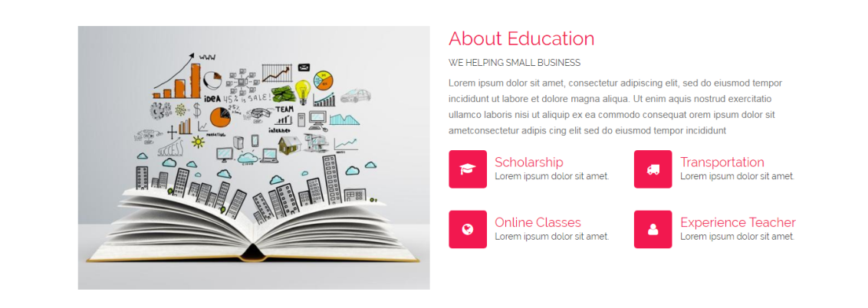

* From the Director's Desk



**Gallery**

<http://max-themes.net/demos/kingster/gallery.html>

**Events and news**

<http://website-sample.in/1.Design-Sample/3.Education-Courses-and-Colleges/edulearn-demo/>

**Apply Online**

<http://website-sample.in/1.Design-Sample/3.Education-Courses-and-Colleges/imfundo/>

**Footer**

**Download**

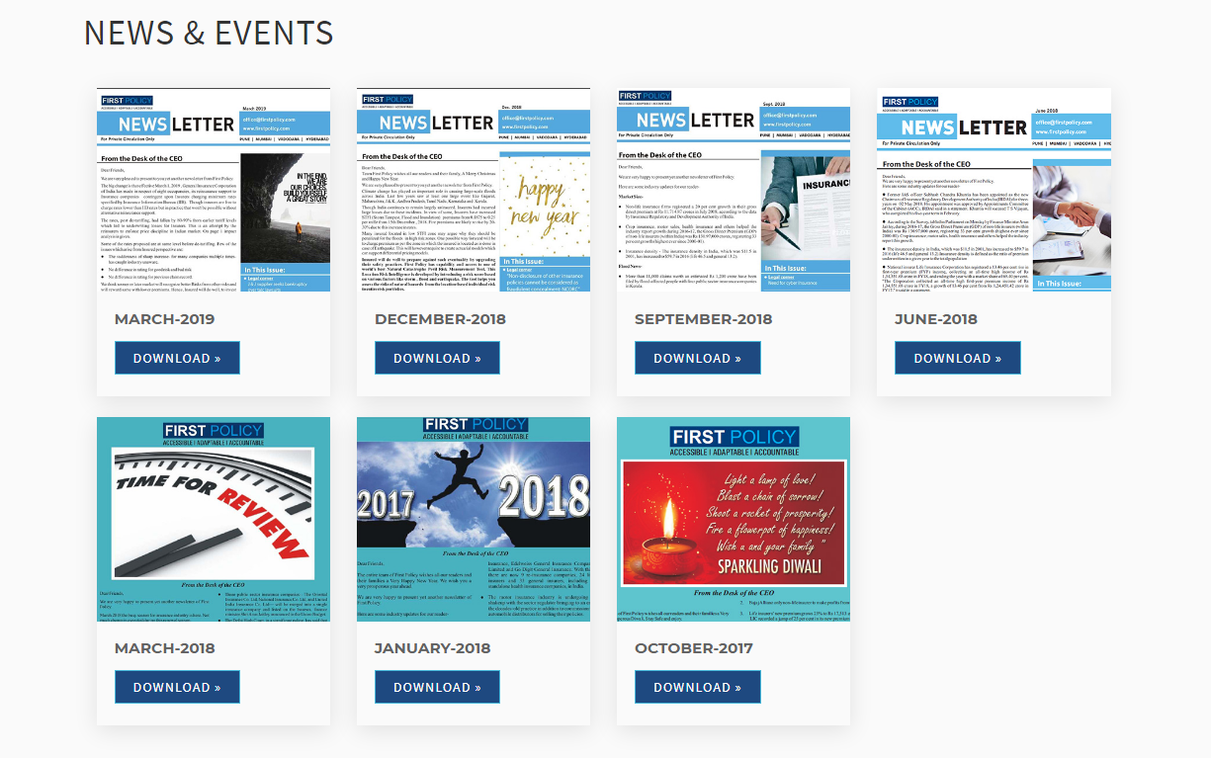

**Apply Online**

<http://website-sample.in/1.Design-Sample/3.Education-Courses-and-Colleges/imfundo/>



**Gallery**

<http://max-themes.net/demos/kingster/gallery.html>

**Events and news**

<http://website-sample.in/1.Design-Sample/3.Education-Courses-and-Colleges/edulearn-demo/>

**Contact Us**

<http://max-themes.net/demos/kingster/contact-2.html>